|  |  |  |
| --- | --- | --- |
| ***Selected Section of the Physical Geodesy and Geodynamics*** | | |
| *PROJECT no. 6* | | |
| **Title: PGG6: Loading deformations** | | |
| **Fikrah Elhifzi Harahap**  **semester 1 group Assignment no. 6** | **Date of delivery:**  **28/01/2022** | **Grade:** |

**1. Presentation of used data, algorithms, equations**

➢ **Used data: Φs = 52.0 / λs = 21.0**

#-----------------------------------------------------------------------

# nr lat [deg] lon [deg] mass [kg]

#-----------------------------------------------------------------------

2 51.98823 20.85781 17595319206.8

2 52.18128 20.95328 18258677088.9

2 51.96291 20.84425 3277214913.1

2 52.13827 20.87259 19708955897.3

2 52.02491 21.03838 14755053753.2

2 51.90622 20.98508 6293068353.5

2 52.19219 20.92314 2067639075.3

2 51.92469 21.16266 15581411005.5

2 51.99333 21.07860 13540613820.8

2 52.19238 20.88294 14946606809.3

2 51.90033 21.03925 2219484550.3

2 51.94939 21.10985 12006637442.9

2 51.97470 20.86300 7607523246.0

2 51.92767 21.09389 17868677610.0

2 52.16173 20.87522 17662751462.1

2 52.17227 21.03192 6752012232.3

2 52.00289 20.97771 3458402069.8

2 52.00138 21.16503 18391440663.7

2 51.85501 21.00465 11961271165.9

2 51.97919 21.06850 8572197212.6

2 52.17537 21.08864 13148889047.2

2 51.90315 20.92657 6359977106.1

2 51.92603 21.12365 3249437956.0

2 52.00048 20.99163 8230769394.1

2 52.02216 20.80884 10088800083.8

2 51.82998 21.08674 5099739109.0

2 51.91075 20.99792 13066713311.7

2 52.04008 20.91670 16217587446.8

2 51.92291 20.80362 6556663351.9

2 52.16737 20.81159 1043353334.3

2 52.15354 21.04030 18879440684.5

2 51.97113 20.91392 3974273768.0

2 52.00504 21.08569 2481438148.8

2 52.00403 20.87150 9826110612.7

2 52.17675 21.01688 2025522671.7

2 52.03396 20.99616 15148272556.8

2 52.14096 20.90481 16434993444.2

2 51.97781 20.99109 12989889238.2

2 52.10992 20.97041 11500727376.4

2 51.90730 20.89675 14172447106.3

➢  **Green function Values :**

|  |  |  |  |  |  |  |
| --- | --- | --- | --- | --- | --- | --- |
| **ψ** [°] | **Gr**  [·R[m]·ψ[rad]/kg·1012] | **Gh**  [·R[m]·ψ[rad]/kg·1012] |  | **ψ** [°] | **Gr**  [·R[m]·ψ[rad]/kg·1012] | **Gh**  [·R[m]·ψ[rad]/kg·1012] |
| 0,0001 | -33,64 | -11,25 |  | 6 | -4,66 | -2,156 |
| 0,001 | -33,56 | -11,25 | 7 | -4,272 | -1,915 |
| 0,01 | -32,75 | -11,24 | 8 | -3,999 | -1,754 |
| 0,02 | -31,86 | -11,21 | 9 | -3,798 | -1,649 |
| 0,03 | -30,98 | -11,16 | 10 | -3,64 | -1,582 |
| 0,04 | -30,12 | -11,09 | 12 | -3,392 | -1,504 |
| 0,06 | -28,44 | -10,9 | 16 | -2,999 | -1,435 |
| 0,08 | -26,87 | -10,65 | 20 | -2,619 | -1,386 |
| 0,1 | -25,41 | -10,36 | 25 | -2,103 | -1,312 |
| 0,16 | -21,8 | -9,368 | 30 | -1,53 | -1,211 |
| 0,2 | -20,02 | -8,723 | 40 | -0,292 | -0,926 |
| 0,25 | -18,36 | -8,024 | 50 | 0,848 | -0,592 |
| 0,3 | -17,18 | -7,467 | 60 | 1,676 | -0,326 |
| 0,4 | -15,71 | -6,725 | 70 | 2,083 | -0,223 |
| 0,5 | -14,91 | -6,333 | 80 | 2,057 | -0,31 |
| 0,6 | -14,41 | -6,15 | 90 | 1,643 | -0,555 |
| 0,8 | -13,69 | -6,05 | 100 | 0,92 | -0,894 |
| 1 | -13,01 | -5,997 | 110 | -0,025 | -1,247 |
| 1,2 | -12,31 | -5,881 | 120 | -1,112 | -1,537 |
| 1,6 | -10,95 | -5,475 | 130 | -2,261 | -1,706 |
| 2 | -9,757 | -4,981 | 140 | -3,405 | -1,713 |
| 2,5 | -8,519 | -4,388 | 150 | -4,476 | -1,54 |
| 3 | -7,533 | -3,868 | 160 | -5,414 | -1,182 |
| 4 | -6,131 | -3,068 | 170 | -6,161 | -0,657 |
| 5 | -5,237 | -2,523 | 180 | -6,663 | 0 |

➢ **Formulas**

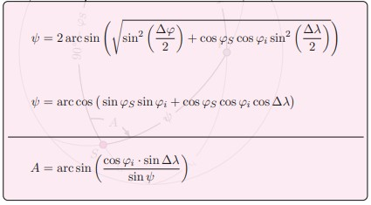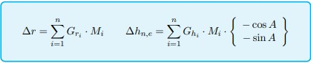

➢ **Algorithms (Matlab)**

%%

clear

%load the data from mydata.txt file containing 9th section of data.txt, we need ϕ, λ and M

data=importdata('data.txt');

phi=data(:,2);

la=data(:,3);

M=data(:,4);

%lets suppose ϕs=52 and λs=21

phi_s=52

la_s=21

%compute ∆ϕ and ∆λ for each value of ϕ and λ

for i=1:length(phi)

delta_phi(i,1)=abs(phi_s-phi(i))

delta_la(i,1)=abs(la_s-la(i))

end

%compute ψ "by both methods of calculation" and compute A

for i=1:length(phi)

result_PHI_1(i,1)= acosd(((sin(phi_s*pi/180))*sin(phi(i)*pi/180))+(cos(phi_s*pi/180)*cos(phi(i)*pi/180)*cos(delta_la(i)*pi/180)))

result_PHI_2(i,1)=2*asind(sqrt(((sin(delta_phi(i)*pi/(180*2)))^2)+(cos(phi_s*pi/180)*cos(phi(i)*pi/180)*((sin(delta_la(i)*pi/(180*2))^2)))))

A(i,1)=asind(cos(phi(i)*pi/180)*sin(delta_la(i)*pi/180)/sin(result_PHI_1(i)*pi/180))

end

%Sort the results of result_PHI_1 by ascending

result_PHI_1_sorted = sort(result_PHI_1)

%load the data from grn.txt file containing ψ, Gr and Gh values for the gridded data set

grh=importdata('grn.txt');

val_phi=grh(:,1);

Val_Gr=grh(:,2);

Val_Gh=grh(:,3)

%convert degree to rad and divided by 10^12

for i=1:length(Val_Gr)

Val_Gr_new(i,1)= deg2rad(Val_Gr(i)/10^12);

Val_Gh_new(i,1)=deg2rad(Val_Gh(i)/10^12);

end

%Create a grid to perform interpolation

[~, index] = sort(val_phi);

F_Gr = griddedInterpolant(val_phi(index), Val_Gr_new(index));

F_Gh = griddedInterpolant(val_phi(index), Val_Gh_new(index));

%compute Gr and Gh

for i=1:length(phi)

Gr(i,1)=F_Gr(result_PHI_1_sorted(i))

Gh(i,1)=F_Gh(result_PHI_1_sorted(i))

end

%compute ∆r

delta_r = 0.0;

for i=1:length(M)

delta_r = delta_r + Gr(i)*M(i);

end

%compute ∆Hn and ∆He

delta_Hn = 0.0;

delta_He = 0.0;

for i=1:length(M)

delta_Hn = delta_Hn + Gh(i)*M(i)*(-cos(A(i)*pi/180));

delta_He = delta_He + Gh(i)*M(i)*(-sin(A(i)*pi/180));

end

%visualisations of the Green functions

figure('Name','Plots of Greens functions with respect to ψ')

subplot(1,2,1)

plot(val_phi,Val_Gr_new,val_phi,Val_Gh_new);

title(' G = f(ψ) with linear scale of X-axis')

xlabel(' ψ[°] ')

ylabel(' G[·R [m]·ψ[rad]/kg·10^12]')

grid on

legend('Gr','Gh')

subplot(1,2,2)

semilogx(val_phi,Val_Gr_new,val_phi,Val_Gh_new);

title(' G = f(ψ) with logarithmic scale of X-axis')

xlabel(' ψ[°] ')

ylabel(' G[·R [m]·ψ[rad]/kg·10^12]')

grid on

legend('Gr','Gh')

%visualisations of the Computed Green functions

figure('Name','Plots of the computed Greens functions with respect to ψ')

subplot(1,2,1)

plot(result_PHI_1_sorted,Gr,result_PHI_1_sorted,Gh);

title(' G = f(ψ) with linear scale of X-axis')

xlabel(' ψ[°] ')

ylabel(' G[·R [m]·ψ[rad]/kg·10^12]')

grid on

legend('Gr','Gh')

subplot(1,2,2)

semilogx(result_PHI_1_sorted,Gr,result_PHI_1_sorted,Gh);

title(' G = f(ψ) with logarithmic scale of X-axis')

xlabel(' ψ[°] ')

ylabel(' G[·R [m]·ψ[rad]/kg·10^12]')

grid on

legend('Gr','Gh')

**2. Presentation of the results**

|  |  |  |  |  |  |
| --- | --- | --- | --- | --- | --- |
| **ψ [°]** | **A[°]** |  | **ψ [°]**  **<<Sorted>>** | **Gr**  [·R[m]·ψ[rad]/kg·1012] | **Gh**  [·R[m]·ψ[rad]/kg·1012] |
| 0.0883399987949056 | 82.3994402391151 |  | 0.00517536627078896 | -5.79173846968118e-13 | -1.96268569861693e-13 |
| 0.183538649351594 | 8.97956792651159 | 0.0140236677354280 | -5.65345193779079e-13 | -1.95964329174194e-13 |
| 0.102849573302325 | 68.9228604154345 | 0.0228583071204087 | -5.51671855100372e-13 | -1.95401974797143e-13 |
| 0.158910765162228 | 29.4782696158758 | 0.0340421285581425 | -5.34635835384794e-13 | -1.94284905357668e-13 |
| 0.0343297411680327 | 43.4652706071951 | 0.0343297411697126 | -5.34204133699169e-13 | -1.94249766848373e-13 |
| 0.0942297278436155 | 5.60592301144589 | 0.0470364612865872 | -5.15377179660927e-13 | -1.92390324583341e-13 |
| 0.197905360837194 | 13.7729754004800 | 0.0488520796017534 | -5.12715344185957e-13 | -1.92089283666529e-13 |
| 0.125368169049576 | 53.1432794840923 | 0.0529932713167890 | -5.06644040033728e-13 | -1.91402648077884e-13 |
| 0.0488520796029093 | 82.1836003005332 | 0.0603645468711163 | -4.95872179627650e-13 | -1.90161356677647e-13 |
| 0.205381865457244 | 20.4502874834530 | 0.0650704317635648 | -4.89424724558593e-13 | -1.89134691857733e-13 |
| 0.102563842566810 | 13.6582941311887 | 0.0792115104656026 | -4.70050266482557e-13 | -1.86049587068555e-13 |
| 0.0845009702371514 | 53.2501214919487 | 0.0845009702313671 | -4.63235327255649e-13 | -1.84738492461358e-13 |
| 0.0880811683016334 | 73.3614846512651 | 0.0880811682969331 | -4.58673831435060e-13 | -1.83832441921652e-13 |
| 0.0926195482934987 | 38.6905813319643 | 0.0883399987880826 | -4.58344058002977e-13 | -1.83766938979663e-13 |
| 0.178988574959997 | 25.3185085782012 | 0.0892592048073649 | -4.57172906480511e-13 | -1.83534312992324e-13 |
| 0.173382995799389 | 6.48294284565125 | 0.0926195482896297 | -4.52891525263779e-13 | -1.82683901654753e-13 |
| 0.0140236677411964 | 78.0984785788324 | 0.0942297278402951 | -4.50840011030139e-13 | -1.82276409101496e-13 |
| 0.101610396855084 | 89.1568030947630 | 0.101610396852562 | -4.41797074836745e-13 | -1.80351412614575e-13 |
| 0.145018351942733 | 1.13481863549270 | 0.102563842567875 | -4.40795855357308e-13 | -1.80076285267317e-13 |
| 0.0470364612932433 | 63.7684261382073 | 0.102849573302283 | -4.40495807674919e-13 | -1.79993834491437e-13 |
| 0.183633027189131 | 17.2184520819775 | 0.106190314244289 | -4.36987674119786e-13 | -1.79029826600386e-13 |
| 0.106902326613580 | 25.0750713212916 | 0.106902326610634 | -4.36239985353311e-13 | -1.78824367526607e-13 |
| 0.106190314243526 | 45.8955025233499 | 0.111415733021044 | -4.31500428245717e-13 | -1.77521973994548e-13 |
| 0.00517536628745315 | 84.6750409559667 | 0.112438530324891 | -4.30426382217002e-13 | -1.77226834476408e-13 |
| 0.119729279894074 | 79.2586411843947 | 0.119729279894195 | -4.22770319190819e-13 | -1.75123007739019e-13 |
| 0.178239860066003 | 17.5024860520640 | 0.125368169049122 | -4.16848885412659e-13 | -1.73495843664799e-13 |
| 0.0892592048069380 | 0.823672494567650 | 0.143477191680321 | -3.97832484247165e-13 | -1.68270284120154e-13 |
| 0.0650704317646505 | 51.9463473062314 | 0.145018351941080 | -3.96214101942622e-13 | -1.67825565215415e-13 |
| 0.143477191681344 | 57.5774940687958 | 0.152621831768863 | -3.88229638860127e-13 | -1.65631496689699e-13 |
| 0.203513183241706 | 34.5996337633599 | 0.155524956785854 | -3.85181048603159e-13 | -1.64793767732659e-13 |
| 0.155524956787368 | 9.14793476902108 | 0.158910765161967 | -3.81625589445538e-13 | -1.63816755133114e-13 |
| 0.0603645468731083 | 61.4620395942729 | 0.173382995798018 | -3.70087585284472e-13 | -1.59736009711976e-13 |
| 0.0529932713187092 | 84.5087932593705 | 0.177054051022878 | -3.67236381253485e-13 | -1.58702848700747e-13 |
| 0.0792115104689110 | 87.0331060180537 | 0.178239860064904 | -3.66315397145780e-13 | -1.58369121313405e-13 |
| 0.177054051023786 | 3.35165516566231 | 0.178988574957881 | -3.65733891613948e-13 | -1.58158407230241e-13 |
| 0.0340421285679735 | 3.97922653167889 | 0.183538649349703 | -3.62199978432963e-13 | -1.56877860038255e-13 |
| 0.152621831768809 | 22.5058074667746 | 0.183633027188107 | -3.62126677854025e-13 | -1.56851298873415e-13 |
| 0.0228583071342584 | 13.8923989788137 | 0.197905360837452 | -3.51041762825496e-13 | -1.52834574045662e-13 |
| 0.111415733023179 | 9.38727391763130 | 0.203513183242063 | -3.47379204637909e-13 | -1.51387864376563e-13 |
| 0.112438530324776 | 34.5078672878721 | 0.205381865457177 | -3.46296398014646e-13 | -1.50931911467129e-13 |
| 0.0883399987949056 | 82.3994402391151 | 0.00517536627078896 | -5.79173846968118e-13 | -1.96268569861693e-13 |

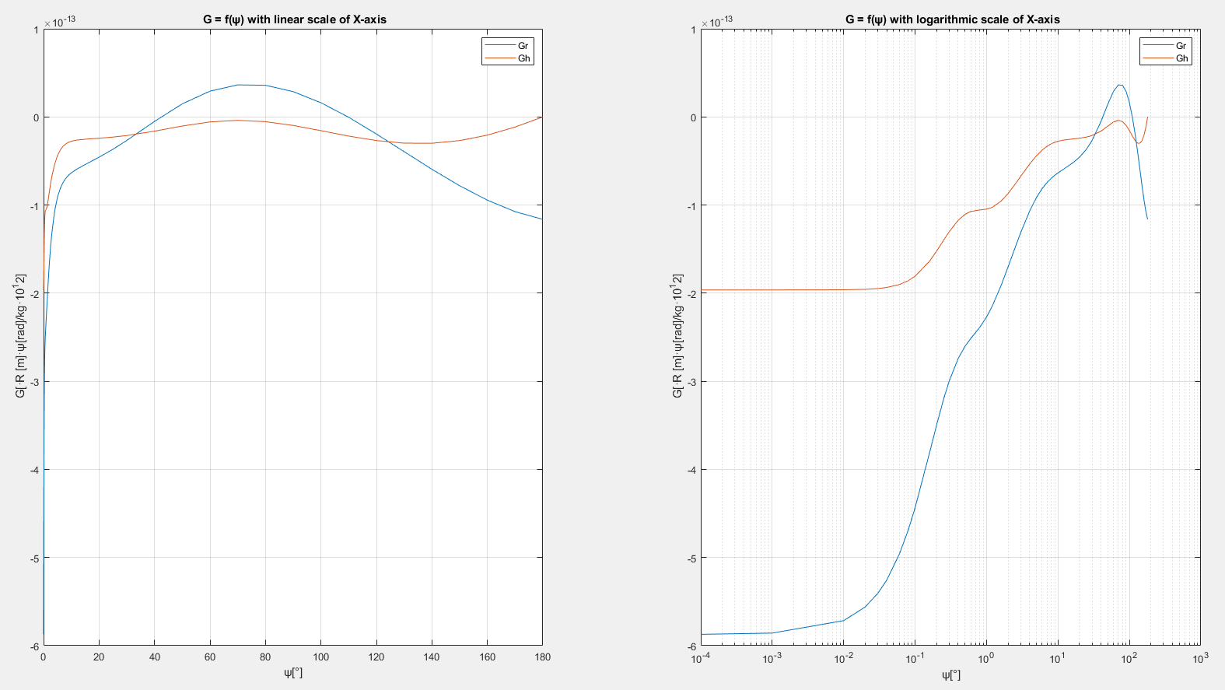

**Figure 1: Plots of Greens functions with respect to ψ**

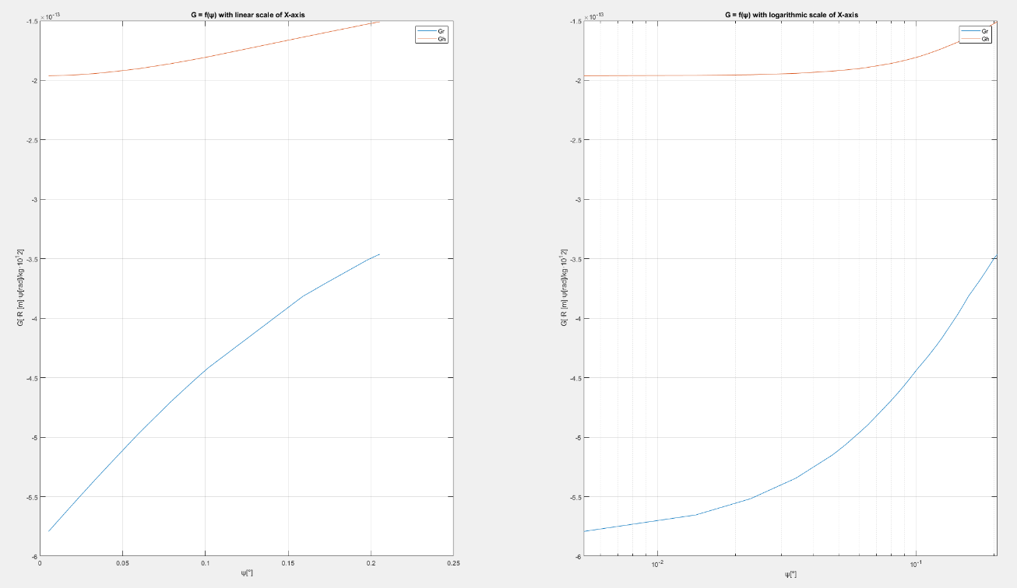

**Figure 2: Plots of the computed Greens functions with respect to ψ**

**∆He = 0.0411007586528055**

**∆r = -0.188374297724426**

**∆Hn = 0.0514187619260279**